CHAPTER 9: Energy transmission
Worksheet 9.4

Refraction
Science Quest 9: pages 314–19
Student: Class:

The appearing coin
1. A coin is placed in an aluminium beaker so that it is just out of sight when looking into the beaker from an angle, as shown. Water is then added to the beaker, so that when the water reaches a certain depth, the edge of the coin can be seen.
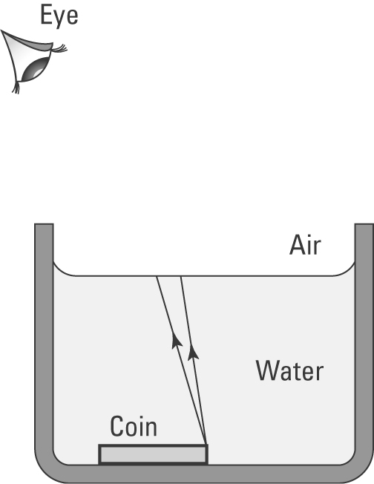 | (a) Use a ruler and pencil to show how the two light rays from the edge of the coin will enter the eye so that the edge becomes visible to the person when the water is added.
(b) Explain why these rays bend as they enter the air.

(c) On the diagram sketch the apparent position of the coin and show why the coin appears to be at a more shallow depth.

Refraction of light through a rectangular prism
2. A light ray is incident on one side of a glass rectangular prism as shown.
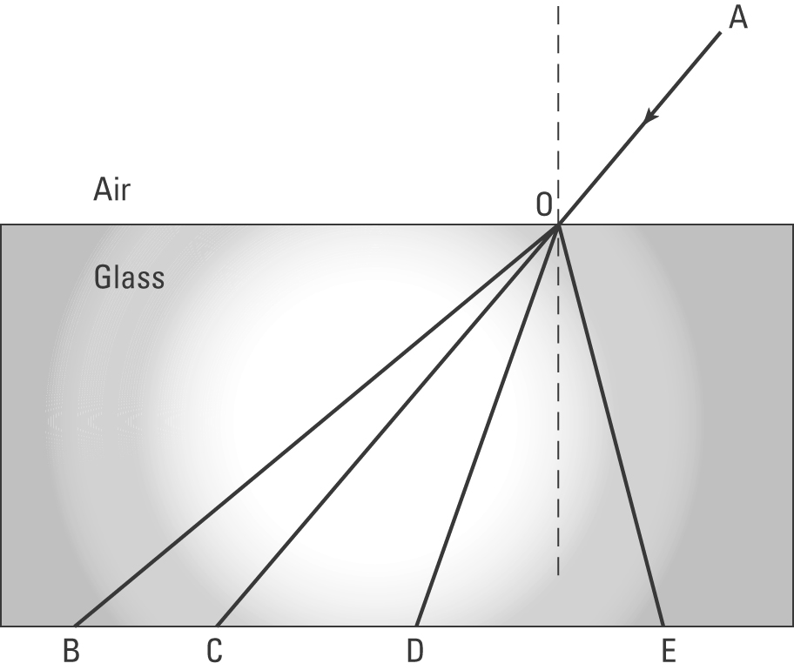 | (a) The light ray travels from A to O. Identify which of the following paths it will take on entering the glass prism.  A. OB  B. OC  C. OD  D. OE  Answer: ........................................................

(b) Use a pencil and ruler to show the path of the light ray as it emerges back into the air at the base of the prism.

